 | IQVIATM Operating Procedure Global Regulatory Affairs – Transfer of  Marketing Authorisation
Document Number and Revision:
CS_WI_RA0275 Revision 4
Document Owner:  Anja De Pauw | Author(s):  Claudine Galea, Veronica Glizer

PURPOSE
To outline the procedures for preparation and application to a Regulatory Authority (RA) for the transfer of Marketing Authorisations.

SCOPE
This work instruction (WI) applies to all IQVIA Global Regulatory Affairs (GRA) staff.

ROLES AND RESPONSIBILITIES
The following roles perform tasks described within this WI:

Role | Sections
Regulatory Project Manager or designee (RPM) | 6.1, 6.2
Regulatory Team Member (RTM) | 6.2
Regulatory Affairs Writer (RAW) | 6.2
Regulatory Affairs Quality Control Reviewer (RAQCR) | 6.2

DEFINITIONS
Not Applicable

MATERIAL AND EQUIPMENT
Not Applicable

PROCEDURE
The workflow diagram for this work instruction is in Appendix A. The main steps involved in the preparation and application for the transfer of marketing authorisations are:
- submission planning
- regulatory requirement collection
- preparation and review
- submission
- post-submission follow-up
- approval
- archive

  - Project Planning

No: | Who: | Step: | When:
6.1.1 | RPM | - Refers to CS_WI_RA0273 (Global Regulatory Affairs - Project Management of Standalone Projects) for the project management of standalone projects.  - Writes a Project Instruction (refer to CS_TP_PL0073: Project Instruction) if required by CS_WI_RA0273.  - Determines whether a submission plan is required. This may not be required for small projects, i.e. Marketing Authorisation Transfers (MAT) of one product in one  country, or where the customer prepares and maintains the submission plan. | At start of project
6.1.2 | RPM | - Requests the customer to provide general information related to the concerned product(s) that may impact the MAT process planning, such as but not limited to, marketing status, ongoing or planned variations, renewals already submitted or to be submitted during MAT timeframe, local distributor/representative, etc., in each country involved.  - Develops and maintains a submission plan in a format agreed with the customer, i.e. MS Project or PowerPoint presentation, which should include relevant data such as the list of deliverables (products by country), key timelines and prioritization for tasks and milestones, comments/issues impacting deliverables, identification of risks, severity and mitigation/action plan, or any other information required by the customer. The minimum required details to be included in any submission plan include but are not limited to:  - Country  - Product name and strengths  - Current Marketing Authorisation Holder  - New Marketing Authorisation Holder  - Current Reference country, if applicable  - New Reference country, if applicable  - Planned MAT submission dates  - Expected MAT approval dates  - RA approval timelines  - Ongoing and/or planned submissions, if applicable  - Submissions required before MAT submission, if applicable | When IQVIA is required to prepare a submission plan, as agreed in the Scope of Work

- Provides the submission plan to the customer for review, discussion and updates as needed. As this is a dynamic document, subsequent updates may occur during the project to adjust deliverables and timelines. Discusses and agrees both the initial plan and any subsequent adjustments with the customer, i.e. via meeting minutes or email, and provides an updated version of the plan to the customer.
- Distributes the final submission plan to the team members.
- Prepares an internal MAT document tracking tool to keep record of each submission package prepared for the customer. The submission plan can be used for this purpose or can serve as a basis to develop the tracking tool e.g. Excel spreadsheet. Minimum requirements to be included in this tool: country, product name and strengths, expected and actual submission and approval dates, RAW and RAQCR names, delivery date of draft and final versions to the customer.
- Documents and reports variances (i.e. timelines, supply constraints, buyer’s capabilities) from the agreed submission plan to the customer, as well as the rationale and remediation action, if required, in the updated
submission plan. Documents deviations communicated to the customer, e.g. via email or meeting minutes.
6.1.3 | RPM | - Agrees with the customer (in writing, i.e. in the submission plan, via e-mail, or in the Project Instructions (if applicable)) how MAT documents and final packages will be delivered throughout the project, such as e-mail or a shared platform such as SharePoints.  - Agrees with the customer (in writing, i.e. in meeting minutes and Project Instructions) on who will be responsible for the MAT submission.  - Agrees with customer (in writing, i.e. in meeting minutes and Project Instructions) if follow-up of MAT submissions by IQVIA will be required and the frequency. | At start of project

  - Project Execution

No: | Who: | Step: | When:
6.2.1 | RTM | Regulatory Requirements for the MAT:  - Collects the current list of regulatory requirements and timelines for the preparation of the MAT packages in accordance with the Scope of Work. These requirements  are obtained from RA websites or Regulatory Intelligence | Before preparation of MAT packages

No: | Who: | Step: | When:
- Identifies the documents/information from the above list of requirements that are required from the customer (e.g. Certificates of Pharmaceutical Product, current Summary of Product Characteristics, Patient leaflet and labels) and either informs the RPM or requests them directly from the customer, as agreed with the RPM. Requested documents may also include the customer’s templates and letterhead paper.
- Follows up the receipt of source documents/information from the customer and alerts the customer of delays that may impact IQVIA deliverables.
- Highlights to the customer the country requirements that might need a longer time to be provided (e.g., local Pharmacovigilance Responsible Person, Certificate of Pharmaceutical Product (CPP) or documents which need legalisation and/or notarisation).
- Agrees with the customer on the format of the final deliverable to the customer, e.g. only electronic Word documents, final-for-submission package (i.e., Electronic Common Technical Document (e-CTD), Non-eCTD
Electronic Submissions (NeeS), paper, other) as per the target country’s submission requirements.
6.2.2 | RAW | MAT Package Preparation and Review  - Follows CS_WI_RA032 (Global Regulatory Affairs – Preparation, Quality Control and Provision of Regulatory Affairs Deliverables) to prepare a MAT package based on the corresponding country’s regulatory requirements and using the source documents/information provided by the customer. | During Project Execution
6.2.3 | RAQCR | - Performs Quality Control (QC) review of a MAT package as per CS_WI_RA032 (Global Regulatory Affairs – Preparation, Quality Control and Provision of Regulatory Affairs Deliverables).  - Records the QC of a MAT package as per checklist template CS_TP_RA0294 Global Regulatory Affairs - Quality Control (QC) Checklist for a MAH Transfer Application, or other checklist as per project specific needs and/or as agreed with the customer.
6.2.4 | RAW | Implements the QC comments received from the RAQCR on the documents as per CS_WI_RA032 (Global Regulatory Affairs – Preparation, Quality Control and Provision of Regulatory Affairs Deliverables).

No: | Who: | Step: | When:
6.2.5 | RTM | - Delivers MAT documents to the customer for review and approval after QC changes have been implemented.  - If changes are required following customer review, sends to RAW and RAQCR to perform necessary updates and QC accordingly. Once updated, delivers updated documents to the customer.  - Once documents are approved by the customer, requests translation and/or legalization (certification provided by a given official entity in the issuing country, such as the Hague Apostille or the Embassy/Consulate of the recipient country) of documents from the customer or to IQVIA’s  vendors, if required and agreed with the customer in the Scope of Work.
6.2.6 | RPM | Oversees the process for preparation and QC performed by the IQVIA team as well as the timely delivery to the customer, by means of the internal MAT tracking tool which is maintained by the RPM or delegate.
6.2.7 | RPM, RTM,  RAW, or RAQCR | Flags up any delay at IQVIA’s end to all appropriate stakeholders and provides appropriate justification. | During Project Execution
6.2.8 | RTM | MAT Package Submission  - If agreed in the Scope of Work and after review and approval of the documents by the customer, prepares the final-for-submission-ready packages. This activity could be performed by the RTM or another department within IQVIA or a third party, as agreed with the customer.  - Delivers the final-for-submission MAT package to the customer. Submission of the MAT to the Regulatory Authority (RA) is generally performed by the customer. | After completed MAT package preparation and review
6.2.9 | RTM | Provides the original proof of submission (i.e., cover letter with the RA’s stamp of “receipt”) to the customer if the submission is performed by IQVIA. Submission by IQVIA is rare and is only possible in countries where IQVIA is allowed to submit on behalf of the MAH. | After MAT submission
6.2.10 | RTM | Files deliverables as agreed with the customer, e.g. in IQVIA’s and/or the customer’s electronic document management systems. | After finalising a deliverable
6.2.11 | RTM | Post-submission follow-up  - Follows up with the RA on the status of the submitted package (review ongoing, questions, approved, rejected, etc.) and informs the customer accordingly. | After MAT submission, if required by the customer

No: | Who: | Step: | When:
- Provides support with preparation of responses to questions/additional information requested by the RA. If responses to RA will be submitted by IQVIA then the preparation of responses to questions needs to be done in alignment with CS_WI_RA010 Global Regulatory Affairs -
Conducting and Documenting Communications with Regulatory Authorities.
6.2.12 | RPM or RTM | Approval  Informs the customer and applicable stakeholders within 5 working days (or as indicated by the customer) after approval communication from the RA is received when IQVIA is responsible for the MAT submission. | After MAT submission, if IQVIA is in charge of checking approval with the RA
6.2.13 | RPM or RTM | Archives and returns documentation as outlined in CS_WI_RA0273 (Global Regulatory Affairs - Project Management of Standalone Projects). | After project completion or as agreed with the  customer

- SUPPORTING DOCUMENTATION
DOCUMENT NUMBER | TITLE
ESOP References
7.1 CS_WI_RA0273 | Global Regulatory Affairs – Project Management of Standalone Projects
7.2 CS_TP_PL0073 | Project Instruction
7.3 CS_WI_RA032 | Global Regulatory Affairs – Preparation, Quality Control and Provision of Regulatory Affairs Deliverables
7.4 CS_TP_RA0294 | Global Regulatory Affairs - Quality Control (QC) Checklist for a MAH Transfer Application
7.5 CS_WI_RA010 | Global Regulatory Affairs - Conducting and Documenting Communications with Regulatory Authorities

- SUPERSEDES
DOCUMENT NUMBER | TITLE | REVISION NUMBER
8.1 CS_WI_RA0275 | Global Regulatory Affairs – Transfer of Marketing Authorisation | 3

- MODIFICATION FROM PREVIOUS REVISION
CHANGE | SECTION REFERENCE | JUSTIFICATION
Updated role name to RTM | 3.0 and 6.2 | For consistency across GRA work instructions.
Removed text in 2nd bullet point “located in ELVIS” | 6.1 | All IQVIA controlled documents are available in ELVIS

CHANGE | SECTION REFERENCE | JUSTIFICATION
Added Project Instructions | 6.1.3 | To ensure that any agreed ways of working with the customer is also captured in the Project Instructions
Various bullet points moved to separate rows | 6.2 | To ensure clarity on responsibilities and for when tasks need to be made
Addition of reference to “CS_WI_RA010 Conducting and Documenting Communications with Regulatory Authorities” | 6.2.11 | To ensure that if the IQVIA team are responsible for submitting responses to RA this is done in alignment with process as defined the SOP.
Addition of reference to “CS_WI_RA010 Conducting and Documenting Communications with Regulatory Authorities” | 7 | New reference added

- APPENDICES

  - Appendix A: Marketing Authorisation Transfer Workflow

Appendix A: Marketing Authorisation Transfer Workflow

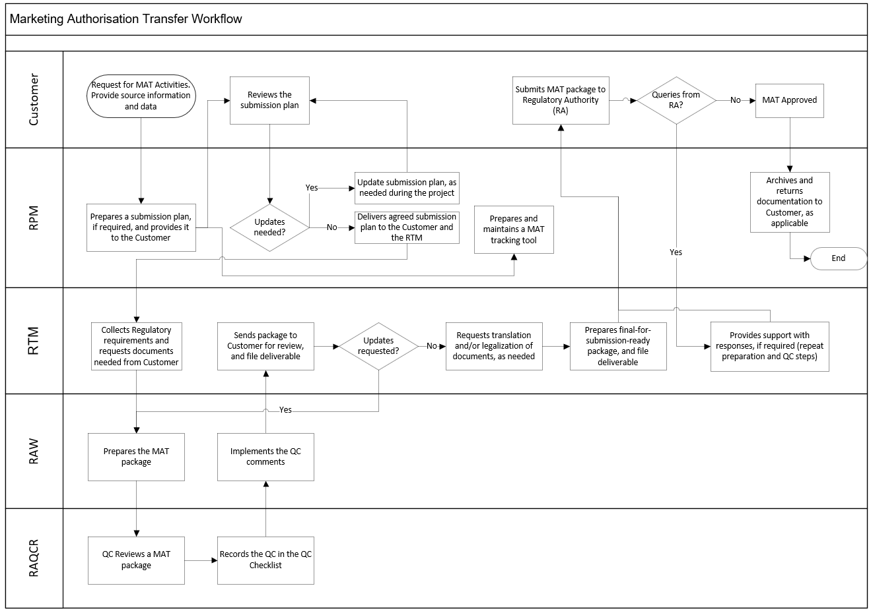

Page 9 of 9
Copyright © 2015, 2017, 2019, 2021 IQVIA. All rights reserved. The contents of this document are confidential and proprietary to IQVIA Holdings, Inc. and its subsidiaries. Unauthorized use, disclosure or reproduction is strictly prohibited.

UserName: Lewicky, Tamara (q730348) Title:
Date: Wednesday, 14 July 2021, 08:50 AM Eastern Time Meaning: Signing this Document Indicates My Approval
================================================

UserName: Lobo, Zena (q833472) Title:
Date: Wednesday, 14 July 2021, 09:07 AM Eastern Time Meaning: Signing this Document Indicates My Approval
================================================

UserName: Galea, Claudine (q769301) Title:
Date: Wednesday, 14 July 2021, 09:10 AM Eastern Time Meaning: Signing this Document Indicates My Approval
================================================

UserName: Kemp, Jaco (q608126) Title:
Date: Wednesday, 14 July 2021, 09:20 AM Eastern Time Meaning: Signing this Document Indicates My Approval
================================================

UserName: Rahman, Maggie (q1033930) Title:
Date: Wednesday, 14 July 2021, 10:25 AM Eastern Time Meaning: Signing this Document Indicates My Approval
================================================

UserName: Glizer, Veronica (q735279) Title:
Date: Wednesday, 14 July 2021, 01:53 PM Eastern Time Meaning: Signing this Document Indicates My Approval
================================================

UserName: Balani, Tarun (q830700) Title:
Date: Wednesday, 14 July 2021, 11:14 PM Eastern Time Meaning: Signing this Document Indicates My Approval
================================================

UserName: Corley, Helen (q730385) Title:
Date: Thursday, 15 July 2021, 03:14 AM Eastern Time Meaning: Signing this Document Indicates My Approval
================================================

